1. In the browser Navigate to our VM WebConnect URL (Say https://<IP>:5002/Myrtille/ ) and enter Login details as below.

*NOTE: This will automatically redirect to the “HTTPS” version, Accept the Certificate and Continue*

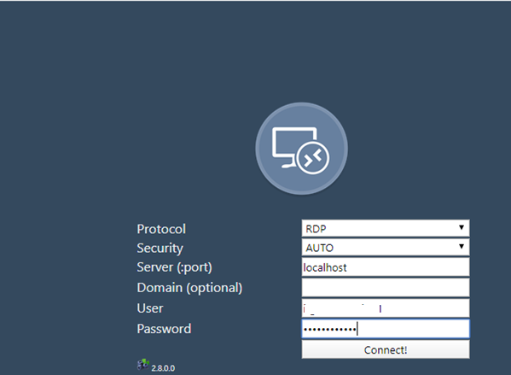

1. Click Connect
2. Make Chrome Full Screen
3. Press the … to make the RDP screen to full size

Fig1



Fig2

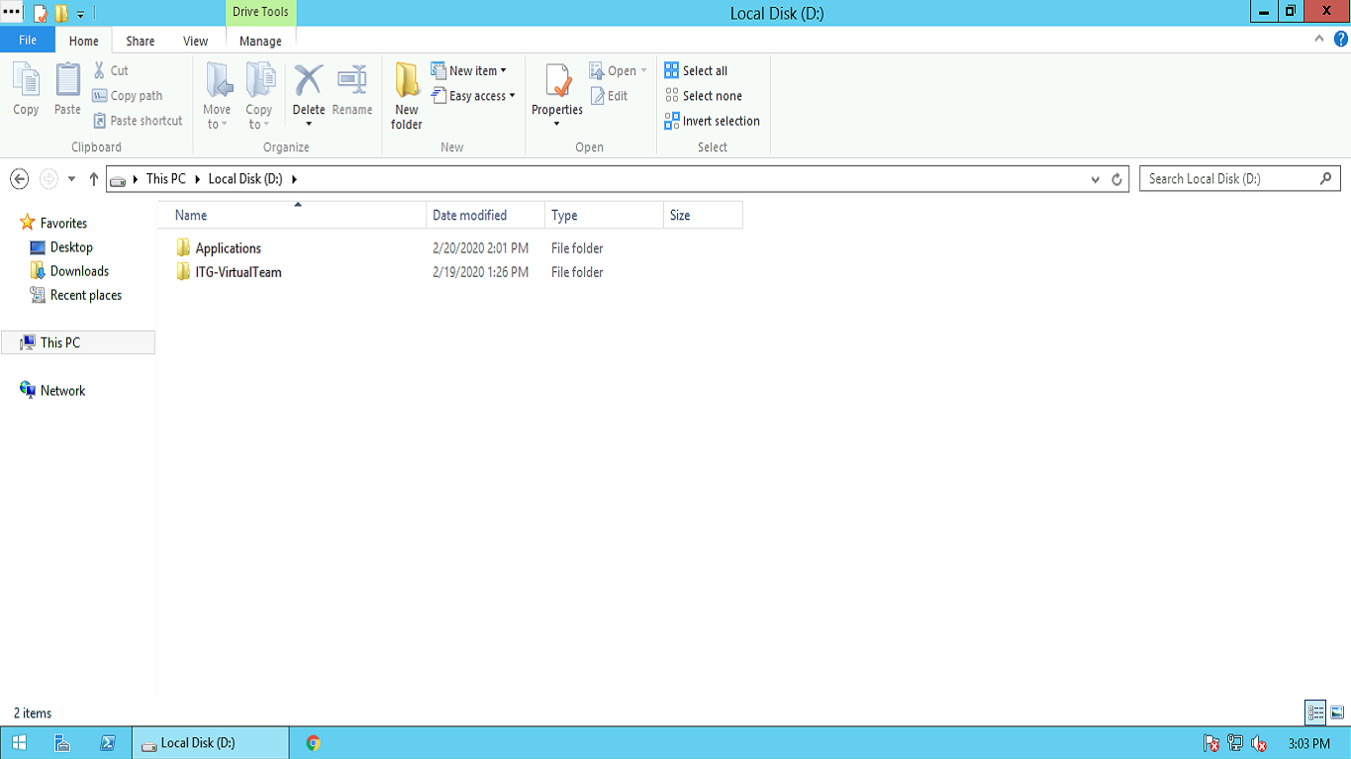

**Troubleshooting:**

1. If you’re facing too slow connection or taking too time loading. Try below

Click on the … button and make HTML5 OFF

